Assignment 4 Session and Cookies

1 –

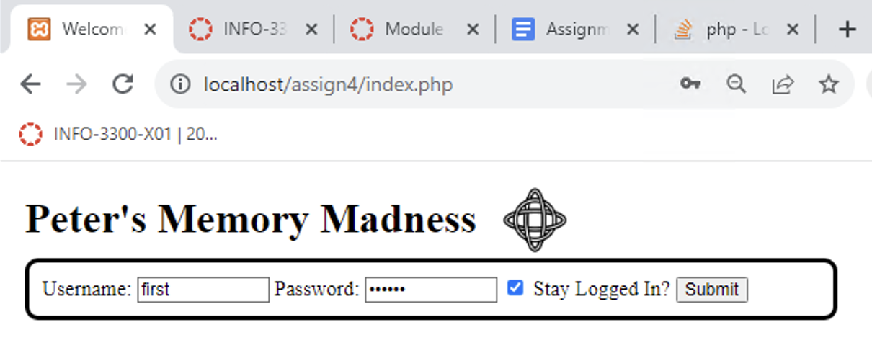

2 –

3 –

